Who Speaks
An Automatic Speaker Recognition System

Zhilei Miao, Yuannan Cai, Wenyu Zhang
The Fu Foundation School of Engineering and Applied Science, Columbia University
New York, NY 10027
{zm2221, }@columbia.edu

Abstract — During a voice messaging session (i.e. sending an audio message on WhatsApp), the client is sometimes used by a couple of people. In this situation, people need to distinguish who is currently speaking rather than simply checking usernames of the clients. Moreover, we want to authenticate whether the user who is currently speaking has the permission to use this client. We hope to leverage the existing speaker recognition technology^{[1]}, with basic messaging functions based on a MQTT client^{[2]} and broker^{[3]}, to build a tool on iOS platform to determine the most likely speaker. The MQTT client also returns the recognition results to the application. Finally the system displays the name of the current speaker and the chatting history on a web page that can be used by a system administrator to monitor the system.
Keywords — Voice Recognition; iOS Application; Web Development; HTTP Request; User Experience Design;

Introduction
With the proliferation of Instant Messaging (IM) and Voice over IP (VoIP) technology, developers are facing the opportunity to improve the user experience. And the combination of modern data anaylsis technology and information transmission becomes increasingly important in the area of application development. Since more than 45 percent of smartphone users take advantage of IM, useful features in these application have a big influence on user’s daliy life.
Traditional IM offers real-time text transmission as an online char type. Users use touchpad to enter text words into the IM client, which send encoded messages to the receiver. In recent years, many IM applications begin to provide voice messaging feature, by which users can directly record they voice sentences easily by the mobile application and send them to the receiver. Voice messaging saves much time compared with traditional text messaging.
Though instant messaging provides users services to send messages to the receiver, there still exist many problems that affect the quality of user experience. In our project, we want to solve the identification problem raised by several people using the same phone to send voice message. Since IM applications are only able to recognize the username of phones, it can’t tell who is exactly speaking. This problem will not only cause the misidentification but also a security problem that a strange may use the phone to send voice message. To solve this problem, we will use machine learning technology to analyze who is speaking on the phone, and how to manage the voice message on a dashboard that can be managed by a system administrator.

System Framework
The overall framework of our project is shown in figure XXX. The system consists of four main parts: the iOS instant message application, the voice recognizer, web back-end server and a web front-end page. Also, there are other important modules including the Java database that implemented on the back-end and the the MQTT broker which is the voice message queue in our system.
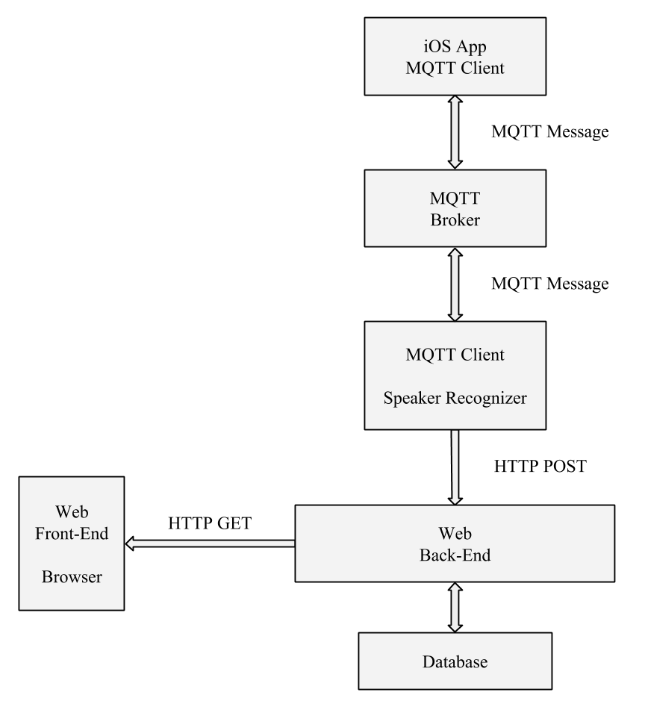
Figure 1
As presented in the diagram, the iOS application sends MQTT message to the broker where the message is then forwarded to the recognition module. At recognition modue, each voice sample is processed and a string is generated representing the name of the speaker. The recognition result and the URL linking to the audio sample is sent to the web back-end in JSON format. The back-end server maintains a Java database and forwards the user information to the front-end when it receives a GET request.
Identify applicable sponsor/s here. If no sponsors, delete this text box (sponsors).

Methodology

Back-end System Implementation
Who Speaks uses a back-end server to store the necessary information and connect the web front-end with the voice recognizer module. We build a RESTful web service as the server. REST (Representational State Transfer)^{[4]} is an architectural style for designing distributed systems. It is not a standard but a set of constraints, such as being stateless, having a client/server relationship, and a uniform interface. REST is not strictly related to HTTP, but it is most commonly associated with it.

Development Environment
We build the server with Apache Maven 3.3.3 as the builder. The developing and running environment is shown in table XXX.
Table 1
Programming Language | Java
Framework | Spring
Architectural Style | RESTful
API | POST, GET
Development OS | OS X 10.10
Running Environment | Ubuntu

Structure and Interface
We build our back-end server based on Spring framework, the structure of the server and the interface between different modules are presented in figure XXX.

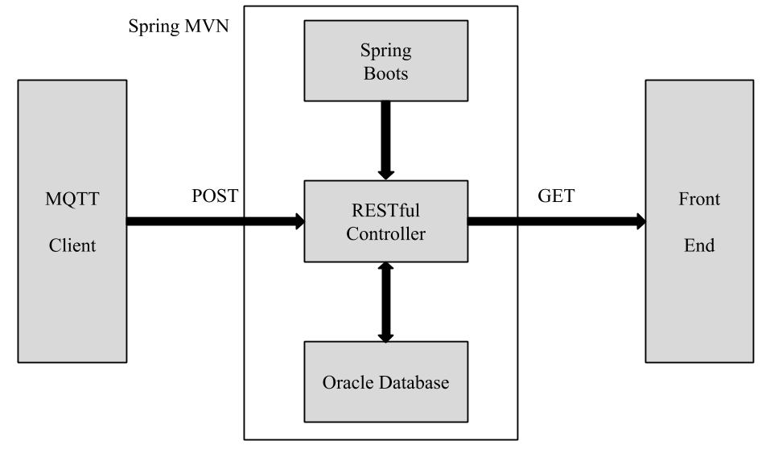
Figure 2
The back-end server consists of three different parts.

- Spring boots module is the launcher of the application, it start the RESTful controller and build an Oracle database table for the server.
- In Spring’s approach to building RESTful web services, HTTP requests are handled by a controller. In our project, RESTful controller is the core module of the server and is designed to handle the POST and GET request from recognizer and web front-end.
- The received recognition results are stored in a Java database and are forwarded to front-end by GET request.

Database
We use Java Database to store the users information and recognition result. Java provides the Java Database Connectivity (JDBC) API to access to the database conveniently. We have one Java database table on the back-end server to store the recognition result as well as the corresponding information for the users. The table is created with four columns storing the increasing IDs for each entry, the recognition result — user names, the URLs linked to the audio sample of the recognized user and the time when the sample is received. The sample content of the table is presented in table XXX.

Table 2
ID  (SERIAL) | Name (VARCHAR) | Audio URL  (VARCHAR) | Sample Time  TIMESTAMP
1 | Yuannan | http:// …… | 2015-05-11 15:56:40
2 | Wenyu | http:// …… | 2015-05-11 15:58:20
3 | Zhilei | http:// …… | 2015-05-11 15:58:40
4 | Wenyu | http:// …… | 2015-05-11 15:59:40

As shown in table XXX, ID is a serial number that increases by 1 each time a new entry is inserted into the table, Name, Audio URL and Sample Time are all SQL VARCHAR type. Name and Audio URL are both sent by the recognition module via POST API. Sample Time is generated when the server receives the new recognition result. It is in the form of “YYYY-MM-DD HH:MI:SS” which is the standard timestamp format in Oracle database.

RESTful Controller
As presented in the diagram of the back-end structure, the RESTful controller is used to handle the POST and GET request.
- The service controller will handle the GET request at /test, optionally with two parameters Offset and Limit in the query string. The method returns a set of recognition result including username, URL to the audio sample and the timestamp in JSON format.
- Similarly, the controller handles POST request at /message, it accepts recognition result in a JSON post with two fields — username and the URL and then store the new coming message into the database.

Speech Recognition
Blank

MQTT System Implemenation
Blank

Front-end Web Application Design

Structure
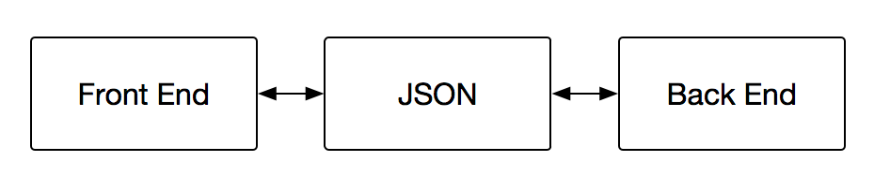
In this project, we split the front end interface and the back end system using JSON. This implementation structure help our design to be clear, and the communication between front end and back end only exits in JSON format list. In our JSON files, we stored user’s name, corresponding voice url and timestamp, which are enough to express the voice information.

UI Design
We split the user interface of our web application into three parts: (1) a new message panel; (2) a starred message panel; (3) system configuration panel.
In the new message panel, we used a real time group list with a function to update the group list every 2 seconds, which guaranteed the three newest voice messages being kept in the panel. Once the list is update, users can either use the playback button at the bottom of the panel or simply click the message label to play the voice message. The new message label in the blue grid will also be updated once a new message has been read. In addition, though the system only shows the three newest messages for efficiency consideration, users can star important voice messages by click the star button, which is similar to the star design in email system. I used an array data structure to store the starred message.
In the starred message panel, users can manage and unstar the voice message. And in the system configuration panel, users can upload some users’ voice samples with their names.
In addition to three main panels, we also implemented some top menu buttons showing the current online users. These features can help users and administrators to control and monitor the voice message.
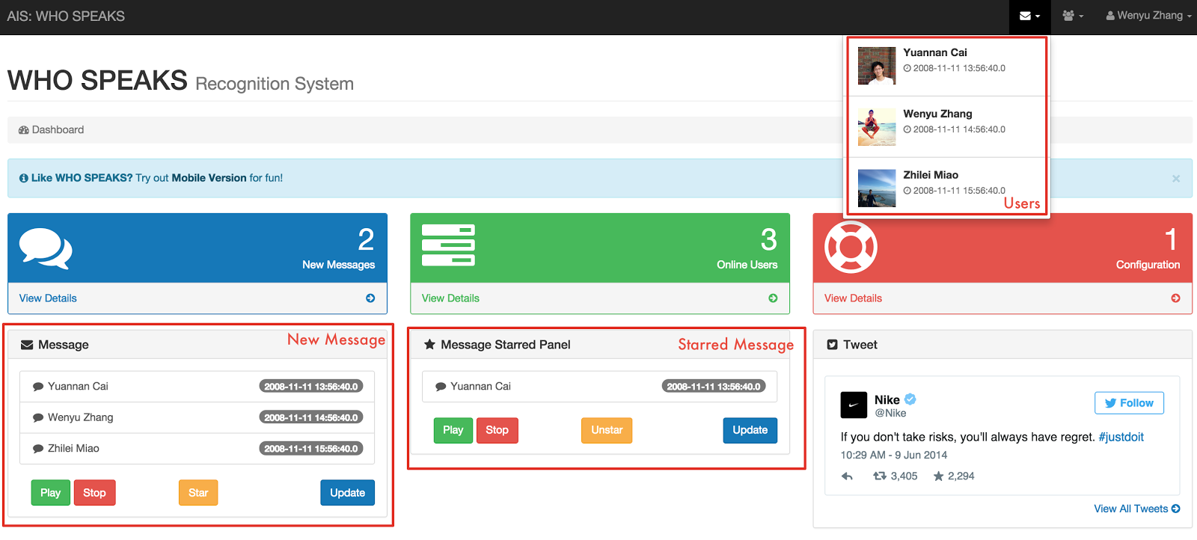

References
- G. Eason, B. Noble, and I. N. Sneddon, “On certain integrals of Lipschitz-Hankel type involving products of Bessel functions,” Phil. Trans. Roy. Soc. London, vol. A247, pp. 529–551, April 1955. (references)
- J. Clerk Maxwell, A Treatise on Electricity and Magnetism, 3rd ed., vol. 2. Oxford: Clarendon, 1892, pp.68–73.
- I. S. Jacobs and C. P. Bean, “Fine particles, thin films and exchange anisotropy,” in Magnetism, vol. III, G. T. Rado and H. Suhl, Eds. New York: Academic, 1963, pp. 271–350.
- K. Elissa, “Title of paper if known,” unpublished.
- R. Nicole, “Title of paper with only first word capitalized,” J. Name Stand. Abbrev., in press.
- Y. Yorozu, M. Hirano, K. Oka, and Y. Tagawa, “Electron spectroscopy studies on magneto-optical media and plastic substrate interface,” IEEE Transl. J. Magn. Japan, vol. 2, pp. 740–741, August 1987 [Digests 9th Annual Conf. Magnetics Japan, p. 301, 1982].
- M. Young, The Technical Writer’s Handbook. Mill Valley, CA: University Science, 1989.

